Amazon prime movie recommendations to users:PRODUCT BASED RECOMMENDATION ENGINE

Big ecommerce firms like Amazon, use product based recommendation system. This means that, once, a user has purchased a product, recommendations to him are made based upon the produts adopted and reviwed by the other users. In this program, the dataset containing movies and their reviews, ratings by the users on amazon Prime are used. Once a user watches a movie, he is recommended as set of movies. For this purpose, the correlation of the movie's ratings columns by the users,with other movies' ratings is calculated. And then , the other movies are sorted based upon the correaltions. The most correlatied movies are then filtered out.
Dataset used contains a user ratings for various movies. The concepts used incluse correlation, regression.

1 Importing various libraries and the dataset

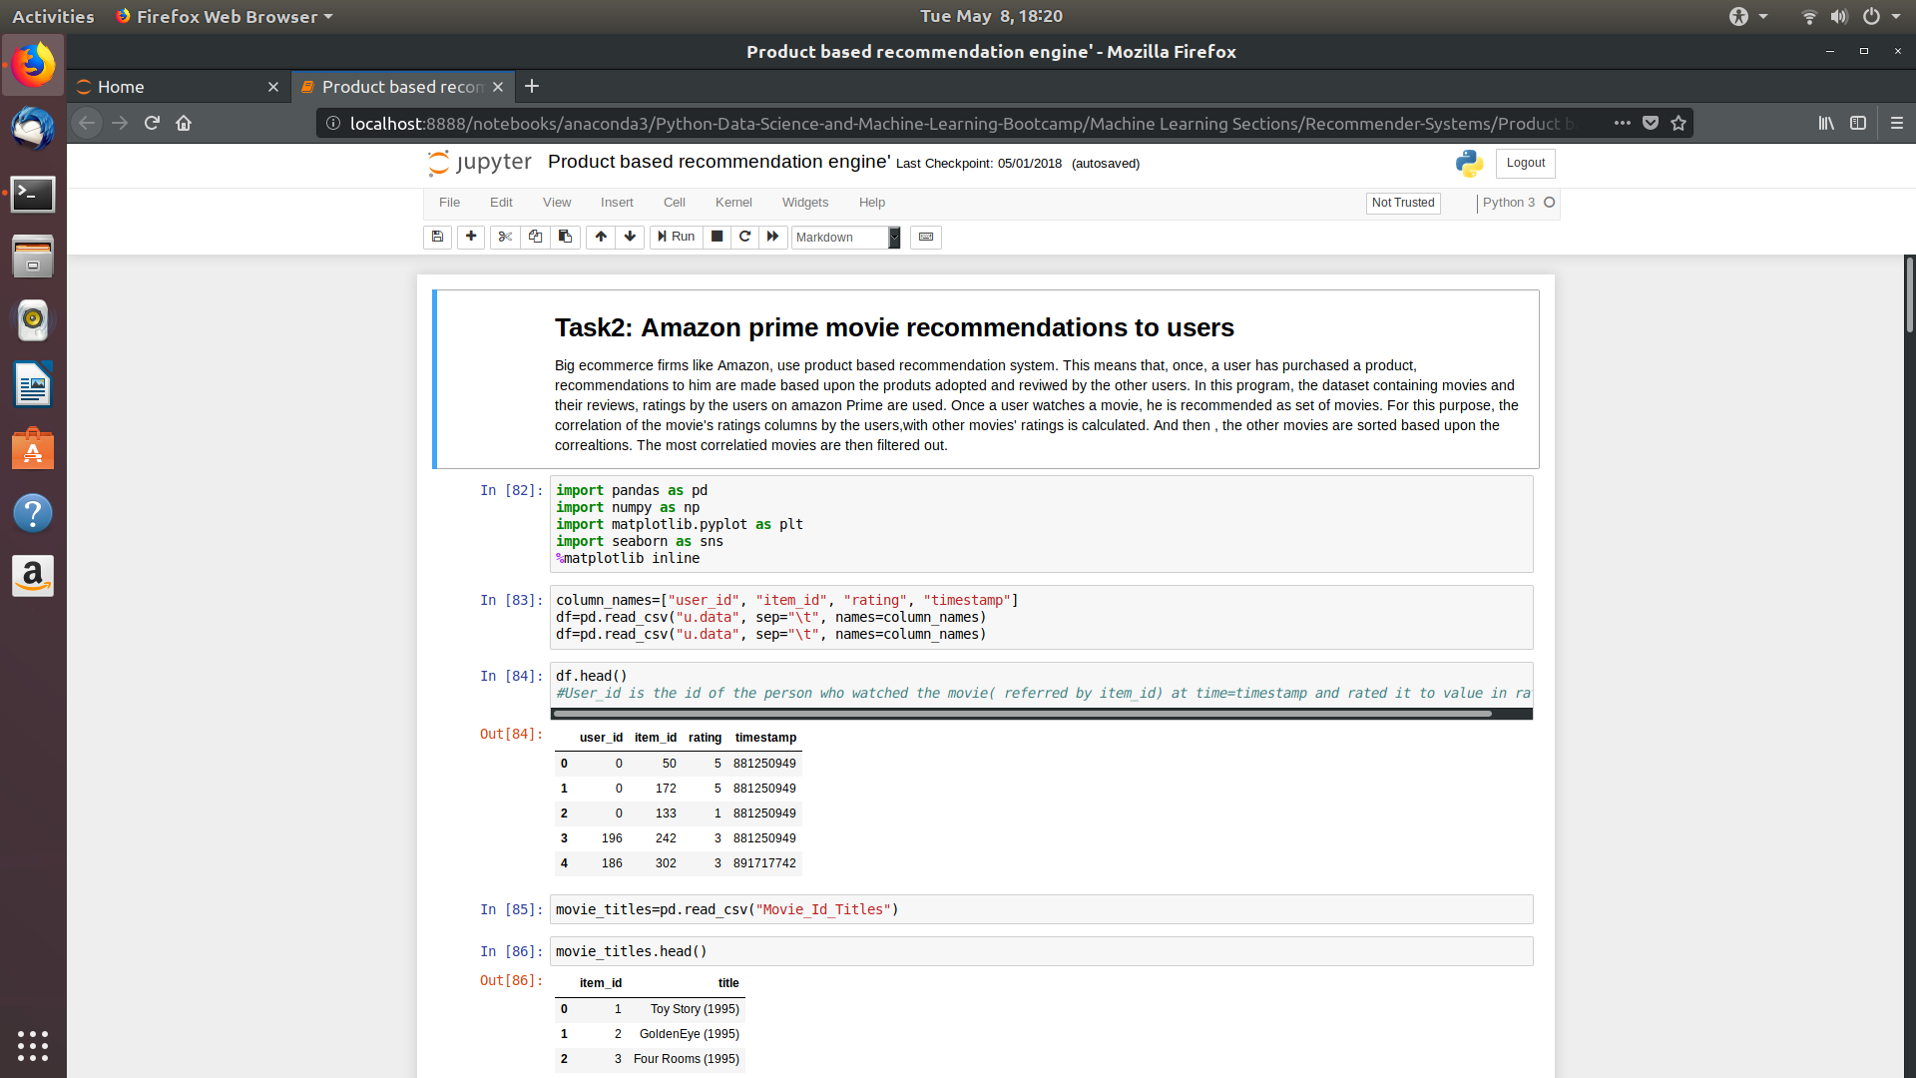

3 Doing some explainatory data analysis

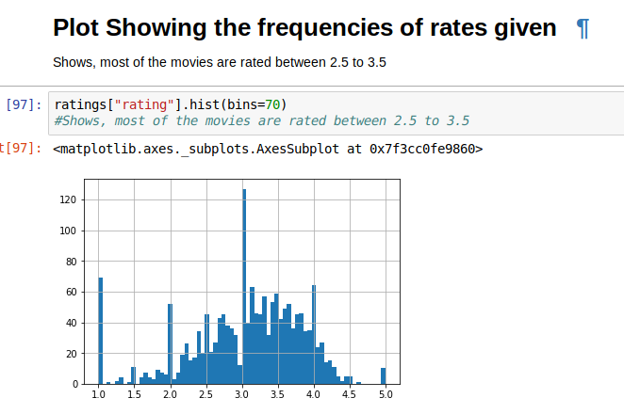

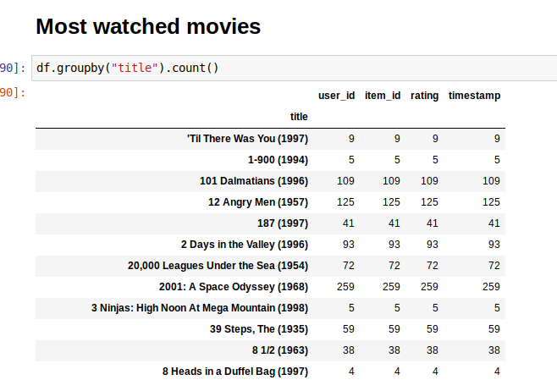

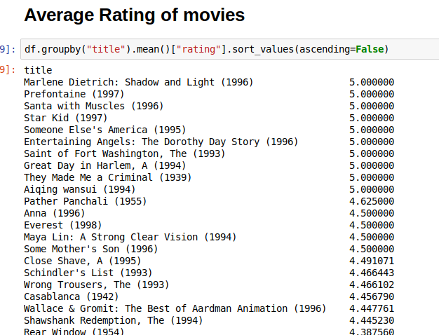

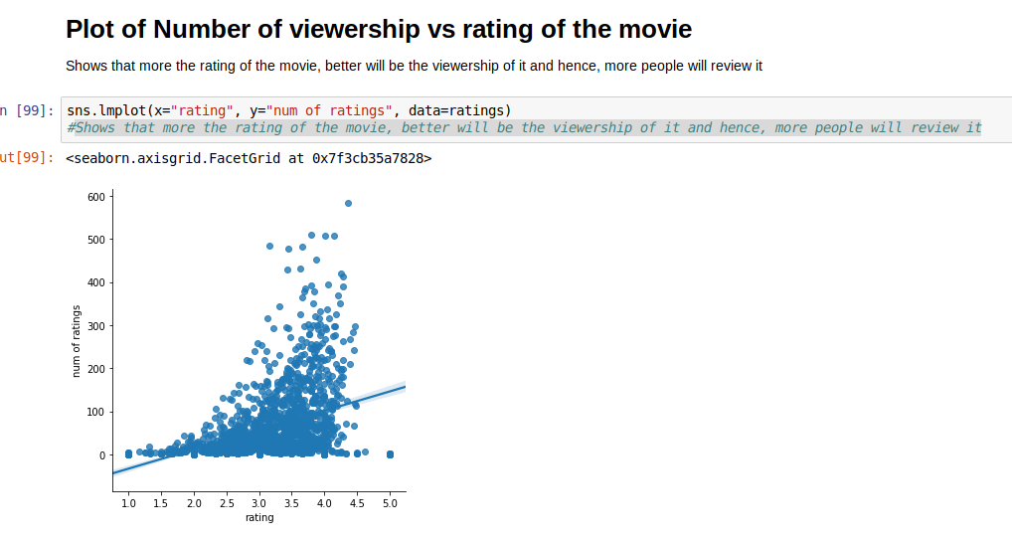

4 Building a recommender based on corelation of item’s user rating with other item’s user rating
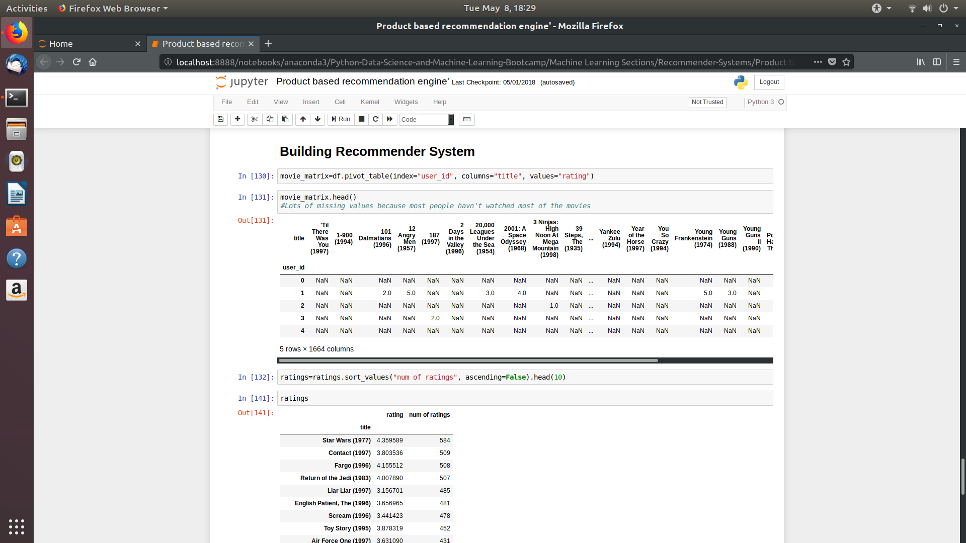

First, we take input of the name of the moview, for which recommendations will be made. That is why, this recommender is called Product based, because, recommendations are based on product and the rating given to it by the users.

Then we grab the user ratings column of the movie/Item and find the correlation of this column with all the other user rating columns of all the other movie. And after that, the movies will be sorted according to the correlation values, and the top movies in this sorted list will be our recommendations.

